

**Kingston Churches Action on**

**Homelessness**

**Bringing hope and support to the homeless**

## QA40335

## **19th ANNUAL REVIEW**

# Report on work for the period

1st April 2011 to 31st March 2012

**Is Housing all there is to Homelessness?**

Some would look at the issue of homelessness and say that the issue is just about finding housing for a homeless person. They might say “There are empty houses. Why can’t they use them to house homeless people?”

Oh, that life were that simple! Firstly, the housing may not be readily available at a reasonable cost to use – but secondly, we must also look at the underlying issues which have caused the homelessness in the first place.

If someone has drug, alcohol or gambling issues, these must be addressed first or future rent is likely to be unpaid resulting in a further eviction. Similarly, if someone has large debt liabilities, there is need to make agreements with creditors and a budget needs to be firmly adhered to make any real progress in retaining housing.

Personal circumstances may also have caused lack of motivation. The longer someone is homeless, the harder it will be to recover that motivation. Depression, hopelessness and difficulties in relating to others need to be addressed so that the person can be motivated to find work to pay for their housing. Long term benefits are no longer an option.

All this is a tough job and, at KCAH, we seek to give a helping hand while encouraging our clients to be accountable for their own lives. As we do this, we try to show God’s love and compassion in action. Thank you for continuing to support and pray for our work.

**Bob Bailey**

**Editor**

**November 2012**

**CONTENTS**

|  |  |  |
| --- | --- | --- |
|  |  | **Page** |
| 1 | A Word from the Deputy Chair | 2 |
| 2. | Operational Director’s report | 4 |
| 3. | Housing Crisis Intervention Service | 5 |
| 4. | The Joel Project | 6 |
| 5. | Some Housing Advice Statistics | 7 |
| 6. | A Few Success Stories | 8 |
| 7. | The Winter Night Shelter | 9 |
| 8. | The Access Project | 10 |
| 9. | Some Access Project Statistics | 11 |
| 10. | Finance Report | 12 |
| 11. | Thank You | 15 |

Page 1

**1. A Word from the Deputy Chair**



Soon after last year’s AGM, Phil had to take time out for personal reasons and, as Vice-Chair, I stepped into the breach. When I picked up the baton, we were having some staff problems which were making it difficult to operate our service, but with God’s help and a lot of hard work we have turned the corner. I take this opportunity to thank Matt, Vicky, Jan and Laura, who worked extra hard and went that extra mile to get the team through this very difficult period. Now, with new staff, the whole atmosphere has changed, stress levels have fallen, and there is an air of optimism and a positive drive for the future.

Despite the difficulties at the time, the night shelter project last winter was a great success, with 30 guests sheltered over the three month period, with many of these being found secure accommodation by KCAH staff. With some short-term funding, we have been able to appoint Daniel Wheeler as an Activities Co-ordinator. He has made great strides in giving homeless clients a sense of worth and feeling part of the community. Daniel has now expanded his role into outreach and is often out in the early mornings linking in with rough sleepers in the Borough and encouraging them to come to KCAH. We now have to secure full-time funding for Daniel’s job so that he can continue with the good work he has already started,

When KCAH started out, the thrust was to arrange a roof over the heads of our clients. Today, it is also about changing the outlook and attitude of our clients. Our organisation has to be even more client focused by looking at their needs and aspirations and assisting them to achieve their goals.

Housing does not always resolve someone’s homelessness and, together with other partner agencies, we must strive to help clients build their own secure future with prospects.

There is a national monitoring system that has been developed to measure the effectiveness of charitable organisations based on outcomes. In order to maintain our funding levels and achieve effective results, KCAH is increasingly adopting an outcomes system. This also helps to give our staff a positive measure of their success.

Page 2

To make our work efficient and effective, we need to invest in making our operations fully computerised. This will help reduce repetition, make our files accessible across our team, make statistics much easier to collate and, most importantly, assist in giving our clients a better, more complete experience at KCAH.

We have made a start with a dedicated manual homelessness programme called Outcome Star, which we are hoping to give a three month free computer trial soon. This programme will help us to work with our new outcomes strategy and will fulfil our funders’ requirements.

We are soon to recruit an Employment Development Coach to help our clients with computer skills, writing their CVs and making targeted job applications. I am sure this will also entail contacting employers for possible opportunities, including volunteering.

With God’s help we have weathered the problems and difficulties in 2011-12 but we are not without challenges in the coming year. The houses we rent for the Access Project must meet the standards for Houses of Multiple Occupation which require financial investment by our landlords. In 2013, with Housing Benefit caps being introduced and the introduction of Universal Credit whereby housing benefit will start to be paid directly to our tenants, our rental income may be at considerable risk. We can face the challenge by reviewing our systems to minimise any risk. Perhaps a new computer system will help.

Many thanks to all our staff, volunteers and trustees, as well as the Churches and their members for their continuing work and support. Collectively, this enables KCAH to help people to make positive changes to their own lives from their initial plea for help because they have some housing or benefits need.

QA41186

Finally, I would like to say that the future looks really good. We have a first rate team of staff and volunteers, all of whom provide a positive feel about KCAH. With their hard work, I am sure we will be able to expand our services, make them more client-focused and overcome any obstacles, seen or unseen.

**Ken Lowes,**

**Deputy Chair**

Page 3

**2. Operational Director’s Report**



At the end of the financial year 2011-12, KCAH was in a better position than at any other time since I became Director. This was due to an exceptional year in donations. The generosity of our supporters is quite amazing in these times of national austerity. This, together with the fact that our Housing Crisis Intervention Service (HCIS) was secured by three-year Big Lottery funding, now allows for KCAH to start to be more imaginative and expand its services.

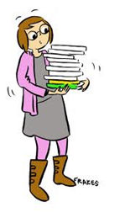The Big Lottery funding stabilising HCIS and money secured for the Kingston Winter Night Shelter Scheme are the prime examples of how investing in the skills of a fundraiser, Becky Mills, has made a huge difference to the fortunes of the Charity. In addition, KCAH is increasingly recognised for the work it does. We were represented on the consultative committee which helped to shape the Council’s 2011-2015 Housing Strategy as well as winning the Kingston Informer and Barclays Bank ‘Let’s Do It’ Award.

[](http://images.google.com/imgres?q=Computer+cartoon&hl=en&tbo=d&biw=1024&bih=462&tbm=isch&tbnid=POZgHSaGLjZVSM:&imgrefurl=http://mycomputerlaptop.blogspot.com/2011/06/computer-cartoon.html&docid=2ly77cU8_UlYxM&imgurl=http://3.bp.blogspot.com/-M6uPV__i9ps/Tfq9vRkSIZI/AAAAAAAAAno/hiz4BC08wCI/s1600/Computer.jpg&w=435&h=450&ei=4HSaUN2DFYSXhQfj2YGYCA&zoom=1&iact=hc&vpx=2&vpy=115&dur=1516&hovh=228&hovw=221&tx=84&ty=103&sig=108030033984515556333&page=1&tbnh=105&tbnw=102&start=0&ndsp=16&ved=1t:429,r:0,s:0,i:139)With threats often come opportunities. Our office neighbours, King’s Church, gave notice and, in order to keep our lease, KCAH had to take on the extra office space. This was not anticipated but gives us the room we need to expand our services. Our thanks to John Lewis for providing computer desks and chairs and to Superhighways for donating second-hand computers which are increasingly being used by our clients for job searches, job applications, claiming benefits online. Volunteers have used the computers to complete online courses, a Mental Health First Aid Course has taken place here and we have been able to hold a client Focus Group to give KCAH feedback on the services it offers. We are in discussion with the Kingston JobCentrePlus to develop ways where we can work in partnership with them to best access work opportunities for our clients and, in particular, for the tenants in our Access Project. We are in a position now to take on for a short term period, an Employment Development Coach to advance this and we shall then look for long-term funding if outcomes demand it.

After a long run of staff retention, KCAH has, in 2012, seen three staff move on. While KCAH has lost a wealth of knowledge and experience, we are also embarking on a very exciting new phase in our history. With the right blend of staffing, people who have fresh vigour and a team ethic, we can be even more successful in taking action against homelessness and supporting those in housing need. Expect KCAH, along with its faith, voluntary and statutory partners, to ward off the threats that lay ahead with welfare reform.

**Matt Hatton,**

**Operational Director**

Page 4

**3. Housing Crisis Intervention Service**

This Advice Service (HCIS) remains a lifeline for so many people in the local community and KCAH is proud of the fact that we really do make a difference to a great many people’s lives. This is reflected in the feedback that we received when we held a Focus Group at the beginning of the year. Equally, the analysis of a questionnaire sent out to clients indicates just how our services are appreciated (visit www.kcah.org.uk).

Although numbers using the HCIS have fallen in 2011-12, we are finding that more complex cases of housing need are presenting at our door and this can be time-consuming. With our national government driving through their policy to reduce the number of people dependent on benefits, this is having an impact on our advice service.

While this government policy may be laudable, the way it is being implemented is questionable. Clients who, in our view, clearly are not ready to work, are attending medicals and being passed fit to work. KCAH is therefore spending much more time submitting appeals and attending benefit tribunals which provide a platform to put the client’s true situation across. Our success rate at the tribunal stage is almost 100%. The increasing expense of holding tribunals must surely deflect from the government’s aim to reduce the amount spent on the benefits system. All the while, the reasons for someone’s need to claim benefits do not properly get addressed.

QA41284The bread and butter of our advice service is to find hostel or night shelter accommodation for homeless clients. This is not a simple process and is exacerbated by the fact that the HCIS advisers rarely now succeed in referring these clients to out-of-borough hostels or night shelters. The way of the world is that clients need a local connection to that borough if they are to be offered help. Therefore, now, HCIS

is almost exclusively restricted to helping clients with a Kingston connection. We are also overly dependent on the local YMCA to accept our referrals. Even then, in most cases, we need to provide an ‘exit strategy’ which will often be our own ‘Access Project’.

QA41123

The face of the HCIS therefore continues to change while remaining pivotal to providing help and support to those who arrive at our door, often in the most desperate of situations. However, with less housing options available than ever before and with forthcoming welfare reform likely to make hard circumstances become critical, the HCIS will need to adapt to the new challenges thrown at it. That is why the HCIS will continue to play an integral part in the success of the Winter Night Shelter Scheme and the Outreach and Tenancy Sustainment work that KCAH is embarking on.

**Matt Hatton,**

**Operational Director**

Page 5

**4. The Joel Project**

The Joel Community Trust envisages a permanent shelter of 14 bed spaces to provide sanctuary for the homeless in Kingston on the site of St Peter’s Church, Norbiton. The project will also offer a purpose built office for KCAH as well as having the facilities to become the main ‘hub’ for homeless people and the disenfranchised.

Progress has been made in the past year to make the vision of the Joel Project a reality. Planning permission was granted by Kingston Council in early 2012 and the sole focus now is to raise the capital costs to bring the Project to fruition. This is the major challenge and the Trust needs to identify ways to attract the ‘big money’.

Equally, individual supporters are also a crucial element to achieving success. This is the backbone to KCAH and is recognised as a key element to making The Joel Project happen.

The Trust has achieved its aim to have 70 ‘Gideons’ by this stage – supporters who are donating regular, monthly amounts to raise finance and which will help to sustain the Project. Other work is also taking place – for example, taking the vision of the Project to the business community in Kingston.

KCAH continues to work very closely with the Trust because we recognise that this is the way forward to achieving the ‘No Second Night Out’ philosophy of the government. KCAH strongly believes that rough sleeping is going to become more prevalent in Kingston. The Joel Project is going to be a major factor towards ensuring that rough sleepers do not become ‘entrenched’ on the streets and measures can be put in place to break the cycle of homelessness.

**Matt Hatton,**

**Operational Director**

Page 6

**5. Some Housing Advice Statistics**

Most of our clients are aged 25 to 50



Relationship breakdown continues to be the main cause of homelessness. Rent arrears are second

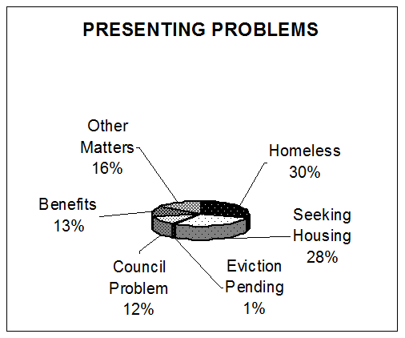

Housing is very short in supply and 58% of our clients are homeless or seeking housing. Benefit needs have increased

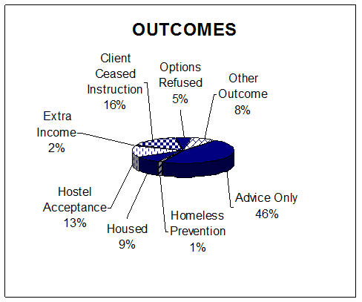

46% take advice and 22% find hostel spaces or housing

Page 7

**6. A Few Success Stories**

*(Please note that names of clients have been changed to maintain confidentiality)*

**Miss Forest** had been street homeless for a couple of years. Sometimes she was able to sofa surf but often she outstayed her welcome. She was not addressing her drug habit and was regarded as a ‘predator’ on other vulnerable people in the borough. She fed her habit by shoplifting and was also suspected of carrying out some serious assaults. She was in and out of prison. Her chaotic nature and inability to engage with agencies wanting to support her for any length of time meant that she continued to sleep rough. Her health was deteriorating and she ended up in hospital having seriously injured a limb. If she had stayed on the street, she was likely not to survive. KCAH was able to help Miss Forest successfully apply for temporary accommodation. Once off the streets and away from the situations that prevented her from getting help, her condition stabilised. She began engaging with the Drug Intervention Programme (DIP) team and addressing her issues. Although her housing is still precarious, she remains off the streets, her health and wellbeing has improved so that she is far less chaotic. Her offending has stopped and she has not returned to prison.

**Dean** had a place at Kingston University but he did not have the funds to continue his second year. He lost his accommodation with his landlord and was facing street homelessness. KCAH helped Dean to get short-term accommodation through the DePaul Trust before he was accepted by the local YMCA.

**Abeeku** had private rented accommodation through the British Legion after suffering a serious injury during his time in the British Army. However, he abandoned it to return to family in Ghana after a relationship breakdown and in the hope that the warmer climate would improve his health. While in Ghana, he discovered that his ex-partner had given birth to his child. As a result, he returned to the UK but without any funds. KCAH helped him to successfully claim benefits and linked him into church events whilst he was sleeping rough. KCAH made a successful referral to London Street Rescue who found Abeeku temporary accommodation until the British Legion stepped in again and found him secure private rented accommodation.

QA40036**Tom** came to KCAH after spending a length of time staying at his uncle’s house until he had outstayed his welcome. He had spent a couple of nights sleeping rough before KCAH was able to place him into the Kingston Churches Winter Night Shelter Scheme and, before that ended, into the local YMCA. It was not long before Tom was referred back to KCAH for the Access Project and he was offered a room. Tom has tried to keep busy by doing some voluntary work with KCAH but he was growing disillusioned and frustrated because he could not find paid work. KCAH helped him to finance buying a suit for interviews but still he was not offered work – until this year. Tom has maintained his employment for several months now and is looking to save sufficient money to be able to move on and rent privately.

Page 8

**7. The Winter Night Shelter**

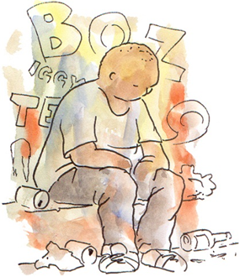The Kingston Churches Winter Night Shelter Scheme opened again and our thanks to Rachel Makin for working as Project Manager and making the Scheme a success. Far more focus was given this year to offering activities to our guests, especially over the Christmas week eg a ‘cook and eat’ competition in partnership with Kingston University.

d217In total, 30 guests used the Scheme with 39% being found more secure accommodation before the scheme ended. This is a significant drop compared to the move-on success of 67% in 2009-10. The figure is reflective of the difficulties that KCAH now faces when exploring housing options for our clients. If KCAH cannot argue that there is a case for the Council to have a statutory duty to help a client, then we are almost totally reliant on the YMCA in Surbiton to accept our clients who ‘fall in the gap’ and who, in housing law at least, are not seen as vulnerable and in priority need. Ironically, with the Council accepting a duty to more people in these times of austerity, it means that less YMCA bed spaces are offered to agencies like KCAH – this only happens if the Council have not filled the spaces.

It potentially means that clients are looking at spending longer periods either rough sleeping or sofa surfing. This is indicative of a housing crisis. The YMCA will only take referrals from us if the client has a local connection and has a solid exit strategy (eg our Access Project accommodation).

With all this in mind, out-of-borough agencies can refer clients to the night shelter scheme if they provide a written commitment that they continue to work with that client to find an exit strategy. The client also has to be fully aware that KCAH cannot assist them with accommodation. Without a local connection, we cannot refer them to the YMCA in Surbiton and similarly, options outside the borough are limited because most places operate a ‘local connection’ rule. This is very restrictive, especially when homelessness often forces someone to live a transient lifestyle.

QA40413Work with the guests never stops when the night shelter scheme ends at the end of each February. Guests who end up back on the streets continue to engage with KCAH and we have found several of them accommodation subsequent to the shelter period. Just this month, in November 2012, one guest who has been addressing some complex support needs, has finally been accepted by the YMCA and if he embraces the help he can get at the Y, he will probably be accepted to our Access Project.

**Matt Hatton,**

**Operational Director**

Page 9

**8. The Access Project**

QA40043We have experienced another challenging but exciting year in the Access Project. Recent Government cuts have meant that many of our tenants experienced sanctions to their benefits and have had to manage on very little money. We are very thankful to the Food Bank who have expanded what we have been doing for several years and successfully helped those experiencing crisis such as this.

One of our houses had problems with bed bugs – they seem to get in everywhere! We have used one contractor several times without success so we tried a new one who seemed to be more thorough and happy to return if problems persist. Our tenants have been very patient and understanding throughout.



One of our female tenants hadn’t seen her children for two years. Her ex-husband and his new wife had custody and were refusing her access due to her alcohol abuse which was caused by the breakup of the marriage. We were able to refer her to a local law firm who have taken her through the legal process so that she can see the children. It was a very painful experience for her and we were able to help her get professional counselling to address the alcohol issues. This year she has succeeded in gaining access to the children and they spend every other weekend with her at the house. Her alcohol issues are also under control now.

We have had a good success with tenants moving on this year. 23 have left our project, ten of those have successfully rented their own private accommodation and eight have secured accommodation via the council’s bidding system. One tenant in particular began in our night shelter two years ago. He has found a full-time permanent job, a privately rented flat and is a committed volunteer with us. He appreciated our help and wants to give something back.

We had a very sad situation this year with a new tenant who came from the YMCA. Shortly after moving into our house he became very unwell. The doctor diagnosed a trapped nerve and a vitamin deficiency. He was so ill I suspected something more serious. One day I accidentally bumped into his friend so we were able to stay in contact and monitor the illness. One day he was so bad we decided to call an ambulance. He was admitted to hospital and I contacted his long lost brother who visited him. A week later he suddenly died of the final stages of bone cancer and a brain tumour. We were able to get the YMCA Chaplain to conduct the funeral because she knew him from his time there. The funeral was lovely with 50 or more friends attending. The Chaplain did an excellent informal service where folk spoke out from their experiences and shared their memories. Many friends came and thanked us for caring for him in his last weeks.

We look forward to another challenging year with massive changes in the benefit system to look forward to. It’s extremely rewarding to be part of a Project which plays such a vital role in the Kingston community helping those who need support.

**Jan Ganney,**

**Housing Support Officer**

Page 10

**9. Some Access Project Statistics**

31% of the tenants in Access Project are from Black and Ethnic Minority backgrounds.



36% of our tenants are aged 18 to 30



62% of our tenants have been in our houses for less than a year.



78% of tenants move on to housing of their own.

Page 11

**10. Finance Report**

**Statement with summarised accounts for the year ending 31st March 2012**

These summarised accounts are extracted from the audited annual accounts on which the auditors’ opinion was unqualified. The trustees approved the full report and the accounts on 18th October 2012.

These summarised accounts may not contain sufficient information to allow a full understanding of the financial affairs of the charity. Copies of the full accounts may be obtained from the Operational Director at KCAH.

Signed on behalf of the Directors and Trustees:

Bob Bailey, Treasurer. 18th October 2012

********************************************************************************

**Review of the Period**

Three services have been provided by KCAH:

The Housing Action Service (offering advice, mediation, advocacy and resettlement assistance) has provided help for 541 new clients during the period and 1149 repeat clients. Advice continues to be given on housing benefit and other welfare benefits to clients through the Housing Crisis Intervention Service. The aim is to prevent loss of housing. Hostel Placement advice helps clients find emergency housing in hostels.

The Access Project (placing and supporting clients in KCAH leased short term shared houses) houses 39 people in 9 houses. We leased a tenth house on 1st September 2012. KCAH continues to improve its housing stock and it gives emphasis to finding further “move on” resettlement opportunities for our clients.

Page 12

**Finance Report (continued)**

**Results for the Period**

During the financial year we received grants totalling £158,951 from the Royal Borough of Kingston upon Thames, The Big Lottery, Lloyds TSB Foundation, King Baudoin Foundation, Kingston Magistrates Poor Box Fund and the London Borough of Merton. These grants were expended on supporting salaries, training and maintaining activities. £10,507 of this money was raised to help run the Winter Night Shelter Project. £70,559 is held over for expenditure in 2012/13 including a further Winter Night Shelter.

The sum of £219,519 was collected from Access Project tenants in payment for their rent and bills. The money received was passed on to landlords and suppliers of utility services. The cost of running our houses amounted to £191,298 including voids, bad debts and minor premises expenditure.

Increased donations (including tax refunds) of £109,707 and investment income of £150 enabled us to end the financial year with a surplus of £83,596. When this was added to the funds brought forward of £90,043, this resulted in a closing balance carried forward to next year of £173,639.

**Future Developments**

A Business Plan covering the years 2012 to 2015 is nearing completion and this outlines the plans for the future of KCAH. It is reviewed annually in May.

During the year we have been delighted to obtain Big Lottery funding to cover the salaries of our part time housing advisers. We also received grant funding of £13,687 for special work in 2012/13. Donations were £30,000 higher than expected and this, together with savings in salaries and running costs, enabled us to carry forward a surplus of £83,596. We are now planning to recruit an Outreach Worker who will support and motivate street homeless people.

In conjunction with local churches, KCAH has helped to operate a Winter Night Shelter. This can accommodate 12 homeless people who would otherwise be sleeping on the streets. We have been able to obtain grant funding for this work and carry forward £24,872 to the winter of 2012/13.

The Access Project maintained its bad debts and voids at an acceptable level and we have continued to run 9 houses.

We express a very grateful “thank you” to the Churches and individuals and to Kingston Council, Merton Council, The Big Lottery, Lloyds TSB Foundation and the King Bedouin Fund who have kindly supplied funding to pay our staff salaries and general costs.

**Balance Sheet as at 31st March 2012**

Tangible Fixed Assets 1,940

Current Assets: Debtors 22,712

Bank current accounts 184,381

Creditors: (amounts falling due within one year) (35,394)

Net Assets 173,639

Page 13

**Finance Report (continued)**

**Statement of Financial Activities for the period 1st April 2011 to 31st March 2012**

|  |  |  |
| --- | --- | --- |
| Income |  |  |
| Donations & Gifts (unrestricted funds) |  | 103,293 |
| Tax Rebate and Interest Receivable |  | 6,414 |
| Grants Received (restricted funds): |  |  |
| RBK |  | 28,562 |
| Lloyds TSB Foundation |  | 10,000 |
| Adobe - King Baudoin Foundation |  | 5,180 |
| Big Lottery |  | 32,254 |
| Supporting People Income - Kingston |  | 28,905 |
| Supporting People Income - Merton |  | 7,805 |
| RBK – Night Shelter Project |  | 30,944 |
| Other donations |  | 15,301 |
| Bank interest |  | 150 |
| Supported Housing Income (restricted funds) |  | 219,519 |
|  |  |  |
| Total Income |  | 488,327 |
|  |  |  |
| Less: Expenditure |  |  |
| Salaries | 145,735 |  |
| Supported Housing Expenditure | 191,298 |  |
| Other Direct Charitable Expenditure | 67,698 |  |
|  |  |  |
| Total Expenditure |  | 404,731 |
| Surplus for the year |  | 83,596 |
| Add: balances as at 1st April 2011 |  | 90.043 |
| Balances as at 31st March 2012 |  | 173,639 |

Page 14

**11. Thank You**

We thank the many organisations and individuals who have given their time to assist the work of KCAH.

**Officers and Committee**

Phil Crump, Chair Retired Mental Health Officer

Ken Lowes, Deputy Chair Retired Public Health Engineer

Bob Bailey, Treasurer Retired Bank Manager

Esther Clarson Housing Manager

Tariq Shabbeer Business man

Eddie Mooney Retired Property Manager

Cathryn Seymour Teacher

Minutes Secretary:

Caroline Ewart Social Worker

**Auditors**

Ark Accountancy

Chartered Certified Accountants and Registered Auditor

31 Cheam Road, Ewell, Epsom, Surrey KT17 1QX

**Bankers**

Lloyds TSB: 83 Clarence Street, Kingston upon Thames, KT1 1RE

CAF Cash Ltd: Kings Hill, West Malling, Kent ME19 4TA

**Funders**

A special thank you to our funders without whom our work could not continue:

Royal Borough of Kingston upon Thames,

Supporting People Fund at Kingston and Merton

Lloyds TSB Foundation

The Big Lottery

Adobe – The King Baudoin Foundation

The Alfred Trust

The Kingston Magistrates Poor Box Fund

Churches Together throughout the Royal Borough of Kingston

Page 15

**Thank You**

We thank the many organisations and individuals who have given their time to assist the work of KCAH and this includes:

**Partners include:**

##### The Churches in the Royal Borough of Kingston;

##### Kingston Voluntary Action; The Community Furniture Project;

Kingston Council; Kingston Churches Housing Association

##### The YMCA; The NHS; Kingston Probation Service

**Staff and Volunteers**

A special thank you to our staff and volunteers for their hard work during the last year:

Matt Hatton Operational Director

Patricia Nabatanzi Housing Adviser

Laura Gafoor Housing Adviser

Vicky Hudson Senior Housing and Resettlement Officer

Jan Ganney Housing and Support Worker

Steve Baughan Accountant (and Angela Adam, Book-keeper)

Rachel Makin Night Shelter Volunteer

Becky Mills Fund Raiser

Andy Kill Administration Volunteer

Su Oliver Administration Volunteer

Bob Bailey Administration Volunteer

Hilary Orton Administration Volunteer

Jim Murphy Administrative Volunteer

Alison Brennan Volunteer Donations Officer

Ann Lloyd Book-keeping Volunteer

**A warm and very grateful “thank you” to the many churches & private individuals who have supported us throughout the year. Your giving, in particular, enables our work to continue.**

Page 16



**Kingston Churches Action on Homelessness**

### 36a Fife Road, Kingston upon Thames, Surrey KT1 1SU

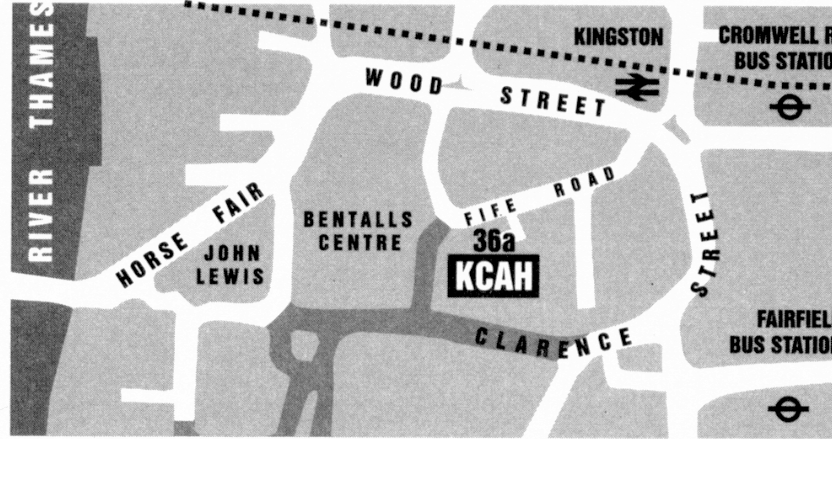

##### Housing Advice Surgery and Hostel Search

The service is open Monday to Friday 10am – 1pm

Clients may “drop in” during these hours for their first visit but, after this, it is necessary to make an appointment to see an adviser.

#### 

#### Telephone: 020 8255 2439 Fax: 020 8274 8405

Email: matt.h@kcah.org.uk

Website: www.kcah.org.uk

Registered Charity Number: 1075890

Company Limited by Guarantee

Registered Company Number: 3735702